**Do you know how to lead people out of a Crisis like the Parkland Shooting?**

**Become a Certified Trained Crisis Responder!**

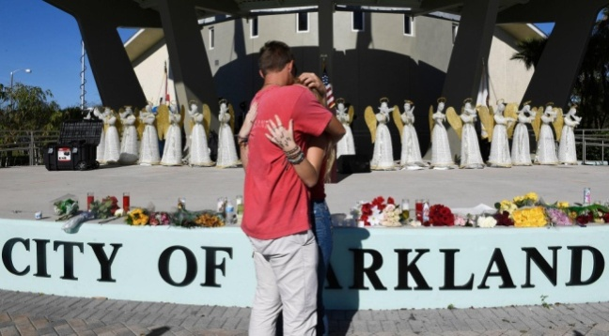

If you were at the scene of a community shooting, workplace suicide, terrorist attack or a catastrophic natural disaster, would you know exactly what to do?

Would you know what to say to protect *that* person from developing **PTSD?**

Would you know what do to protect yourself or those you care about from the dangers of **secondary traumatic stress?**

**Trained Crisis Responder Certification Course**

**February 22-23, 2019**

*(must attend 9am-5pm both days to achieve certification)*

***13 CEUs provided***

*South Florida 2-day Crisis Certification is* ***only $179*** *(advance registration)*

This two-day crisis certification course was designed after the terrorist attacks of 9/11 by clinical experts for the United States National Guard and the International Critical Incident Stress Foundation as a rapid psychological response to community trauma.

It prepares you to manage a major crisis and lead a critical incident stress debriefing session, *(CISD)* while keeping yourself safe from post-traumatic psychological harm.

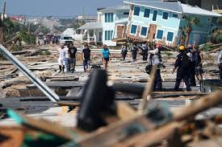There are eight real life training scenarios in this certification class to equip you in dealing with community crisis events. You will learn the early warning signs of PTSD and how to prevent secondary psychological trauma while working as a first responder providing psychological first aid.

This rapid crisis stabilization certification, in partnership with **Florida Mental Health Counselors Association (FMHCA) and Mental Health Counselor’s Association of Palm Beach (MHCAPB)**, is taught by **Dwight Bain** **(The Lifeworks Group)**, an ICISF certified crisis response trainer who worked at Ground Zero after the terrorist attacks of 9/11 and has equipped thousands with psychological survival skills to use until emergency management teams can arrive. More crisis events will come to Florida – are you going to be prepared to help or be a helpless bystander?

***“Up to 35% of those exposed to traumatic events such as disasters and terrorism will develop significant post-traumatic psychological distress and perhaps PTSD.” –U.S. National Guard***

This certification course is for therapists, counselors, counseling students, clergy, teachers, nurses, chaplains and lay counselors interested in crisis response.

**Space is very limited for this Certification - Register now!**

**Trained Crisis Responder (TCR) Certification**

**Registration Form**

**(13 CEUs)**

**Feb 22-23, 2019, 9:00 am - 5:00 pm daily**

**

*ICISF Certified Instructor Dwight Bain*

*In partnership with FMHCA & MHCAPB*

*Training facility: FMHCA Office*

*2101 Vista Parkway, Ste 250, West Palm Beach FL 33411*

**PLEASE PRINT** your name clearly as you would like it to appear on your National Certification

Name: ________________________________________________________________________

Address: ______________________________________________________________________

Telephone: ____________________________________________________________________

E-mail:________________________________________________________________________

______ $179.00 – early bird registration *(before February 8, 2019)*

______ $199.00 - late registration *(after February 8, 2019, if space is still available)*

**Payment Options:**

* Make check payable and mail to: The LifeWorks Group

1850 Lee Road, Suite 250, Winter Park, FL 32789

* Email this registration form with your credit card information to Sola Thompson at **info@lifeworksgroup.org**

* Fax form directly to: **407-647-8874**

*(If course is already full you will be notified before card is charged)*

Credit card number______________________________________ Expiration date ___________

CVV code ________________ Zip code for billing address of credit card __________________

*Refund and cancellation policy: Full refund minus $25 processing fee if notice is given 10 days prior.*

**CE Broker Tracking information**

COURSE NAME: Trained Crisis Responder

TRACKING NUMBER: 20-684840

